Targeting The Menopause
Why Miss Menopause?
The story behind Miss Menopause
Miss Menopause has been created to fill the void of educational services needed by women as they reach the menopause. For most young woman school played a part in wellbeing education. Telling us about puberty and what would happen to our bodies. Sadly in 2019 it’s estimated only 3% of companies across the UK are educating their workforce about the symptoms the menopause may bring.
So why does it matter?
Since 1971 there has been an ongoing decline in men working full time while the opposite is true of women. It’s estimated that in 15 years time the amount of full time working women will equal that of men. The changes to pensionable age brought about in 2010 also mean more women are working for longer than ever before. This trend is set to continue.
Who is affected?
100% of all women will go through the menopause whether they have had children or not. The average age for menopause is 51 in the UK, however some symptoms may begin many years before and can last up to a decade or more post menopause. Mental health issues can often arise during the menopause causing, confusion and a feeling of hopelessness.
Why Miss Menopause?
How might this affect me?
It’s estimated that £7million is lost in absenteeism, however that’s not the problem as estimated as presenteeism is a much greater issue. So you won’t find data as it’s currently hidden. As our workforce ages this is set to increase.
What can be done?
Education is the key. There is an opportunity to educate HR departments who may want to review their wellbeing policies. Managers who need to understand where this fits into diversity and how to work with their people. Most importantly to educate women as to what to expect and how to deal with this time in their life.
If you care about your workforce and you want to get the best from the talent you employ then you need to read on…
Warmest regards,
Sharon MacArthur
Menopause Educator
British Menopause Society Member
Why Me?
My menopause story
My name is Sharon MacArthur, I am 50 years old, the owner of Red Handbag and founder of Miss Menopause. I set up Red Handbag 5 years ago to provide leadership coaching to business leaders.
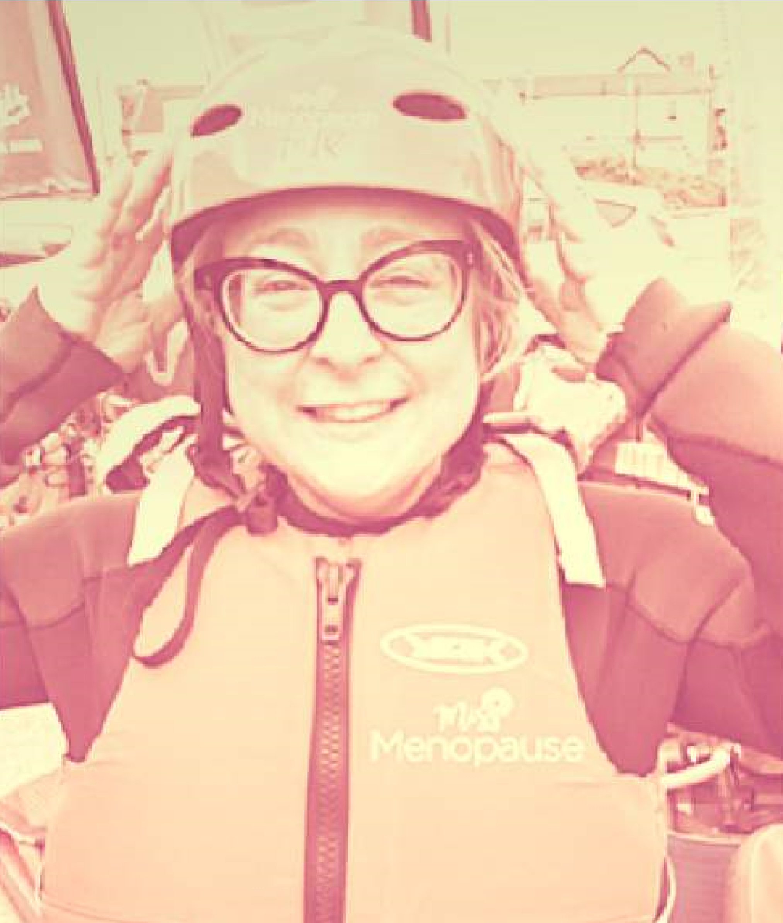
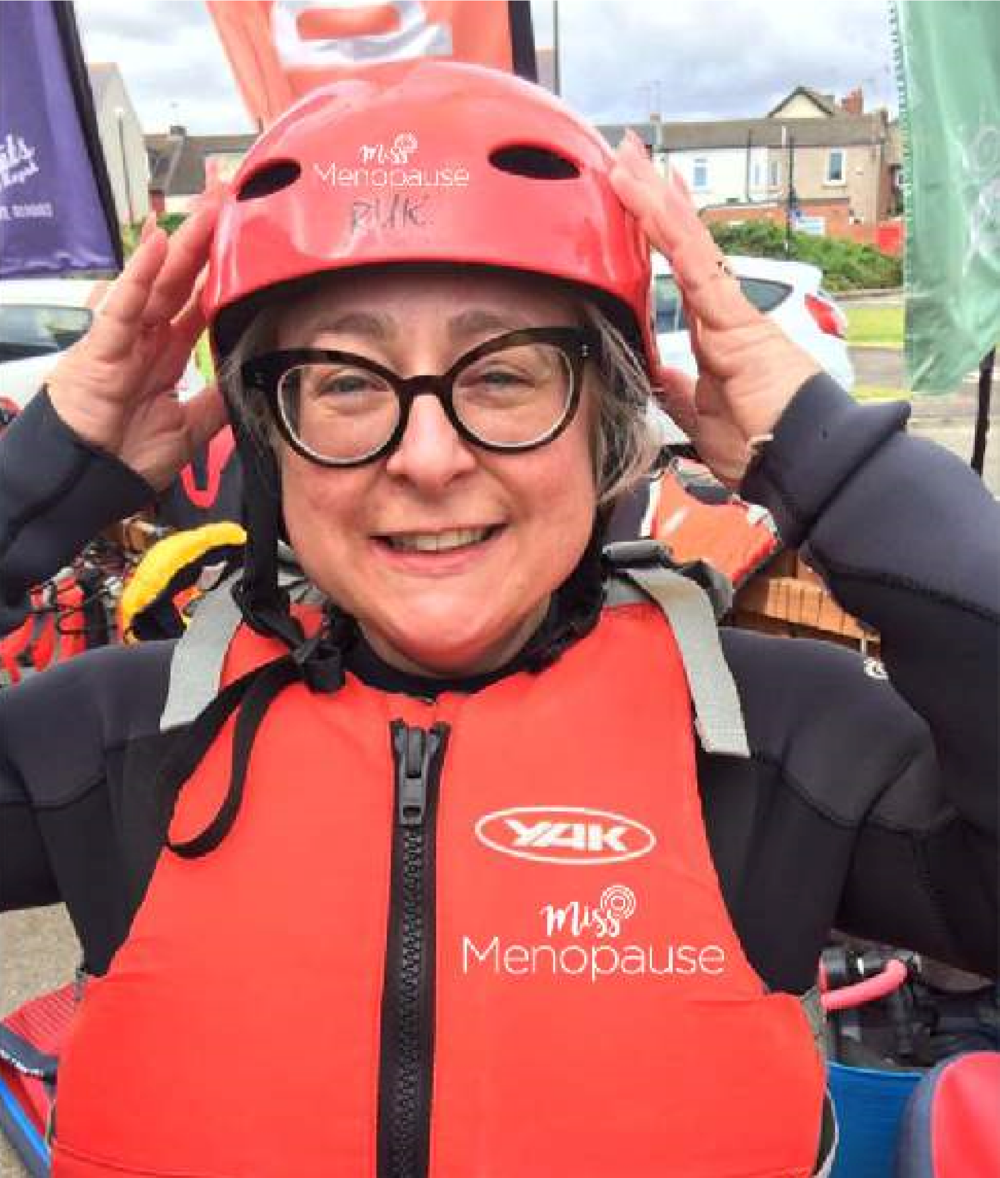
About 3 years ago I began to feel exhausted. I just didn’t feel like me. Things I could do without thinking suddenly became really difficult. I couldn’t remember names, I was tired all of the time. I felt anxious about meeting people and didn’t want to go out.
Then the disturbed sleep began. Ordinarily I could sleep on a clothes line but now I seemed to wake up every hour, leaving me feeling totally drained.
I took to Google to see if I could figure out what was happening to me. After hours of research it dawned on me I was probably going though peri menopause. In other words I was on route to menopause.
Why had no-one warned me? Surely I was too young?
Sadly I found I wasn’t.
Why Me?
The Impact
The final straw was waking up one morning and feeling terrified to leave the house. This continued for a week. I felt unable to leave my room, terrified of the outside world. I knew it was my hormones but I couldn't control it.
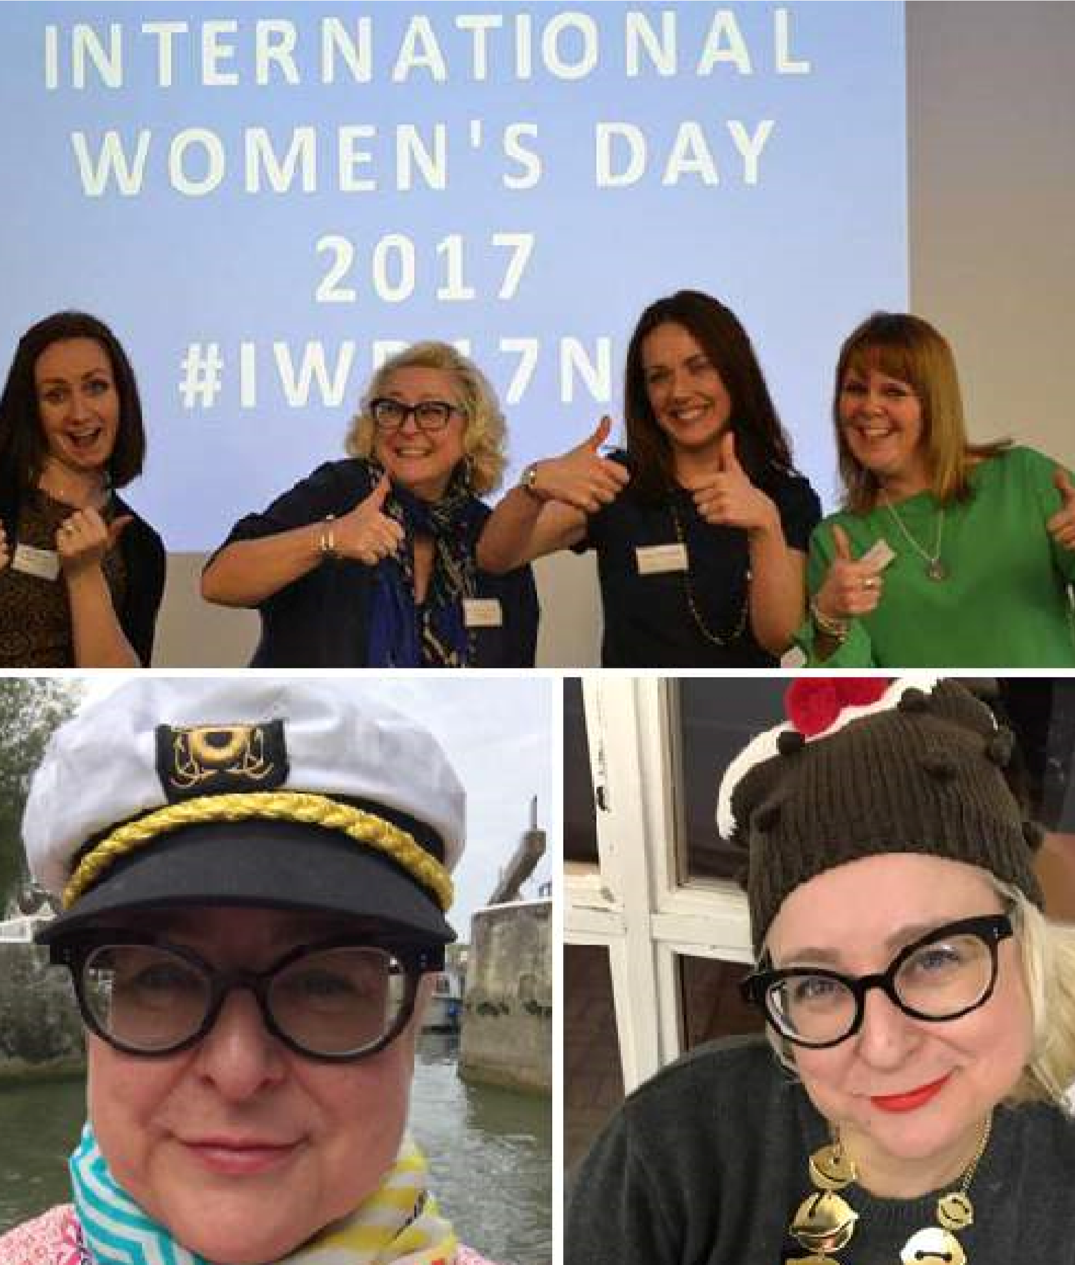
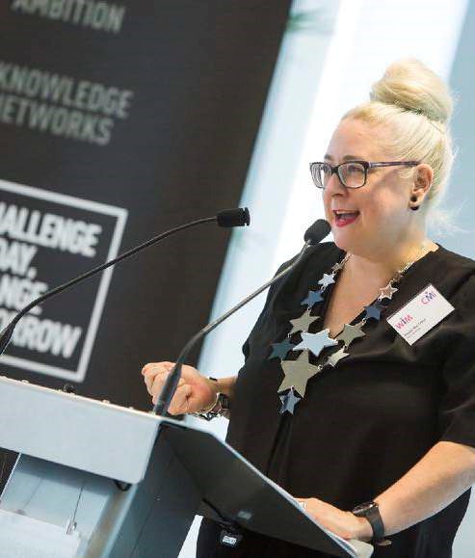
The menopause was causing all of this. Shocked, I began to ask my friends and family to see who might be going through the same thing. Surprisingly the older women I asked said they “just got on with it” but they hadn’t worked at the time. Friends my age didn’t seem to know anything about what to expect.
I was on my own.
Miss Menopause was born from the sad fact that everyone seems to be missing the menopause. As 100% of all women will go through this stage in their lives, it truly seems like the last taboo. I’m on a mission to educate organisations and their employees. To make it ok to talk about the subject and support those women who need it. Menopause can last for 10 years.
If you care about your customers, and your people, missing the menopause is not an option. I’m here to help you…

Miss Menopause for Women
Is the menopause the last taboo? Find out more about how it could affect you.
This is a service for working women who will go through the menopause. Providing information and the opportunity to share stories in a fun and engaging way.
Learn about what the menopause is and what to expect. How best to take care of yourself. Treatments and options open to you and what your plan will be when the time comes.
Miss Menopause for Managers
Would you know how to support a team member going through the menopause? We will educate you on how to best help.
Without the help and support of managers, women struggle to share their symptoms and stories about their menopause symptoms. It’s therefore vital that leaders are educated as to what woman may go through and how to help and support them.
As well as learning about the menopause and its symptoms managers will work through policies and case studies to leave with a plan of how they will support their women.

What we do
Miss Menopause for HR Professionals
Do you know employment law around the menopause? We are here to educate HR Professionals on how to help manage menopausal employees.
Without a change in policies and procedures to support women going through the menopause, its unlikely women will speak up.
Learn all about the menopause and its symptoms, employment law, treatment and options. Discuss and design a plan that you can use to change your culture on how you deal with the menopause.

