Healthy Sleep Habits
Your behaviours during the day, and especially before bedtime, can have a major impact on your sleep. They can promote healthy sleep or contribute to sleeplessness.
Your daily routines – what you eat and drink, the medications you take, how you schedule your days and how you choose to spend your evenings – can significantly impact your quality of sleep. Even a few slight adjustments can, in some cases, mean the difference between sound sleep and a restless night.
Completing a two-week sleep diary can help you understand how your routines affect your sleep. Click on the following link to download a sleep diary https://sleepcouncil.org.uk/advice-support/sleep-tools/sleep-diary/.
The term “sleep hygiene” refers to a series of healthy sleep habits that can improve your ability to fall asleep and stay asleep. These habits are a cornerstone of cognitive behavioral therapy, the most effective long-term treatment for people with chronic insomnia. CBT can help you address the thoughts and behaviours that prevent you from sleeping well. It also includes techniques for stress reduction, relaxation and sleep schedule management.
If you have difficulty sleeping or want to improve your sleep, try following these healthy sleep habits. Talk to your doctor if your sleep problem persists

Quick Sleep Tips
Follow these tips to establish healthy sleep habits:
- Keep a consistent sleep schedule. Get up at the same time every day, even on weekends or during vacations.
- Set a bedtime that is early enough for you to get at least 7 hours of sleep.
- Don’t go to bed unless you are sleepy.
- If you don’t fall asleep after 20 minutes, get out of bed.
- Establish a relaxing bedtime routine.
- Use your bed only for sleep and sex.
- Make your bedroom quiet and relaxing. Keep the room at a comfortable, cool temperature.
- Limit exposure to bright light in the evenings.
- Turn off electronic devices at least 30 minutes before bedtime.
- Don’t eat a large meal before bedtime. If you are hungry at night, eat a light, healthy snack.
- Exercise regularly and maintain a healthy diet.
- Avoid consuming caffeine in the late afternoon or evening.
- Avoid consuming alcohol before bedtime.
- Reduce your fluid intake before bedtime.

Why eating sometimes makes you sleepy
When we’re eating, the stomach is producing gastrin, a hormone that promotes the secretion of digestive juices. As the food enters the small intestine, the cells in the gut secrete even more hormones (enterogastrone) that signal other bodily functions, including blood flow regulation.
But what does this have to do with sleepiness? Well, as we’re digesting our meal, more of our blood is shunted to the stomach and gut, to transport away the absorbed newly digested metabolites. This leaves less blood for the rest of the body and can cause some people to feel a bit “light-headed” or tired.
Still, the body is a lot more sophisticated than that; it doesn’t respond to food volume alone. What you eat is just as important as the size of your meal.
Biochemistry and Sleep

For many years now, researchers have been investigating the link between food and sleepiness, but from another perspective. If we understand more about people’s sleep patterns, we might gain insight into what causes some people to put on weight and develop diseases such diabetes and atherosclerosis (a disease of the arteries that develops with fat deposits in artery walls).
We’ve known for many years that meals with an imbalance of nutrients – that are rich in either fats or carbohydrates – are associated with feeling sleepy. But this is not the case when nutrients are balanced or the meal is rich in protein. And that leads to the burning question: what is causing this effect?

Scientists in Germany have documented that meals high in carbohydrates that also have a high glycaemic index (meaning they release sugar into the bloodstream quickly) cause an increase in the hormone insulin. Insulin promotes the absorption and use of glucose from the bloodstream after a meal. But it also allows the entry of a special amino acid (we get these from the digestion of proteins), called tryptophan, into the brain.
This is important as tryptophan is converted into another chemical in the brain called serotonin, a signalling chemical or neurotransmitter that can be associated with calmness and drowsiness especially in children.

But does eating foods rich in the essential amino acid tryptophan, such as turkey meat, cottage cheese, tofu and bananas, automatically make you sleepy? Probably not, as it’s the insulin surge brought about by ingesting carbohydrates that will allow the tryptophan to enter your brain, along with some other amino acids.
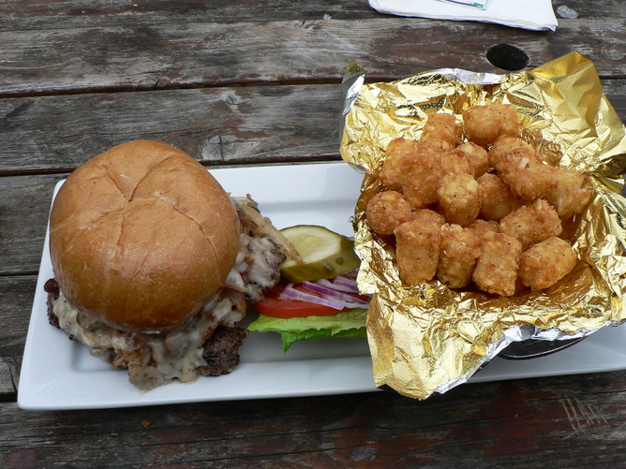

Consuming a high-protein meal, on the other hand, will cause a lot of amino acids to enter the brain and will probably have a stimulant effect rather than a soporific one as the insulin released after eating stimulates their transport across cell membranes.
Cow’s milk drunk warm, often in the evening, for instance, is associated with sleepiness. But it’s the melatonin (a natural hormone that regulates our night or day rhythm) in the milk that can make us sleepy.
First identified in the 1950s, melatonin is a hormone secreted by the pineal gland under the brain. It’s mostly secreted at night, peaking around three or four in the morning. Melatonin acts on receptors in a part of the brain called the suprachiasmic nucleus (a cluster of cells) that triggers sleepiness as part of our sleep-wake cycle. Interestingly, melatonin is found in greater amounts the milk of cows milked in night-time darkness, as opposed to in the daytime.
Sleep Recipes

So overall, where are we now with our understanding of how food influences sleep? The short answer is that it’s complicated and we don’t yet fully understand it.
We know the gut hormones called enterogastrones, which are released when we eat, can influence blood flow. And that some of these hormones (especially one called CCK or cholecystokinin) can directly make us sleepy, probably by influencing the production of the neurotransmitter serotonin and melatonin.
We also know carbohydrates can promote the release of insulin after a meal, which may promote the actions of tryptophan on the brain, again via serotonin.
But to more practical matters: what should you do to avoid nodding off after a meal?
Here are a few suggestions:
- Don’t overeat; watch your portion size. Allow time during your meal for the level of your body’s natural hormones leptin (which reduces hunger) to rise and ghrelin (normally only released when we initiate eating) to fall, thereby lowering your appetite and inducing a feeling of satiety.
- Balance your meal; have protein and carbohydrate in roughly a one-to-two proportion. Include plant-based or marine-based fats rather than animal-based saturated fats in your meal. And don’t neglect any of the major food groups (vegetables and legumes, fruit, grains, lean meats and dairy products), as they all contain some essential nutrients that our bodies cannot manufacture.
- In particular, ensure you are getting all the minerals and micronutrients you need by including a variety of vegetables or salads in your diet, and a modest amount of fruit.
- Avoid “veging out” after the main meal of the day. Once the meal has settled, be moderately active. This will help promote better blood sugar control.
Good eating!

