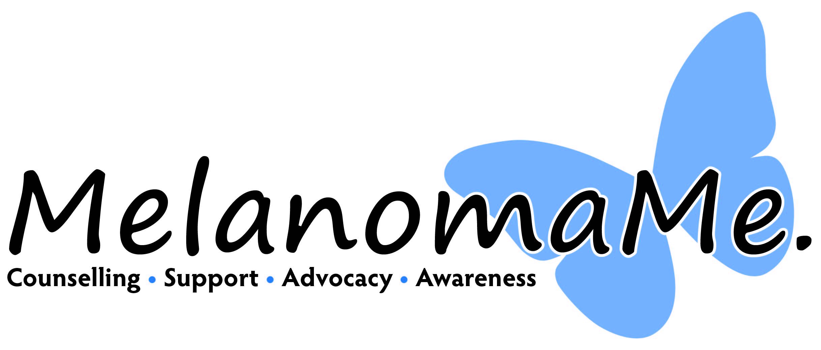

What is skin cancer and malignant melanoma?

Skin cancers such as basal cell, and squamous cell carcinoma are one of the
most common cancers worldwide and are always caused by UV exposure.
Although rarely invasive, they can be incredibly disfiguring.
Melanoma is 86% preventable, meaning that it is mostly caused by harmful UV
exposure. Melanoma is a deadly form of skin cancer that once it penetrates
the skin can spread to any organ. Malignant melanoma rates have increased by
360% since the 1970’s and are predicted to continue to increase becoming one
of the most prevalent cancers in the UK. However, there is still a lack of
understanding and recognition of melanoma, with many members of the
general public not aware of the risks and the necessary precautions they
should take. Melanoma can be very aggressive, making it imperative that
individuals are educated on what it is, the risk factors attributed to it, what it
looks like and be encouraged to seek medical advice as soon as they notice
anything suspicious on their skin.

Why outdoor and offshore workers are at an increased risk
of skin cancer.

Everyone is at risk of melanoma, however outdoor and offshore workers are
more at risk, due to prolonged exposure to harmful UV Rays either in land or at
sea. The sea in particular poses a huge risk, because of the lack of shade and
because of the harmful UV rays reflected from the water. Skin cancer occurs
when the UV rays penetrate our skin and alters our DNA, causing a backup of
cells which ultimately forms a tumour.

Younger Generation and melanoma. “The young persons disease!”

Malignant Melanoma is mostly a preventable cancer, which is very high risk within our younger generation due to the use of tanning beds and unprotected tanning. Awareness and understanding of the full dangers of Malignant Melanoma would give most social groups an insight of how tanning without protection can kill and help to develop education as to what people can do this avoid the risk factor.

Men

Men are a notoriously hard to reach group, when it comes to health related issues and as result have a worryingly worse prognosis for men than women, awareness is of the utmost importance. Most awareness is targeted towards women, therefore MelanomaMe. are making it their mission to reach out to as many men as possible.

What are the benefits of awareness workshops

Although melanoma is such an aggressive disease, there is still very little
awareness out there in the public domain. MelanomaMe. takes a person-centred
approach and offers a one stop service from prevention to support,
covering pre-diagnosis through to aftercare, for everyone effected by
melanoma.

We have worked with some fantastic organisations, raising awareness of
melanoma, including HMRC, Newcastle City Council, BT, Legal Aid Agency, DXC
Technology, Auxillis, Barclays Bank and Muckle LLP.

We measured the impact by inviting participants to complete a
questionnaire following the sessions. The results showed that from the 205
participants, 98 % said that they would recommend MelanomaMe’s
awareness session and 98.54% said that they felt that awareness of
malignant melanoma was important. 96% said that having this heightened
awareness of preventatives and early detection had changed their mindset
around sun safety. This feedback clearly showed that the participants
connected with MelanomaMe. and because of the sessions, behaviours
were changed.

Although in many workplaces, PPE is provided, sunscreen is generally at the
discretion of the employee. However, if the employee has little knowledge of
the dangers of skin cancer, they are unlikely to protect their skin to the best of
their ability. Having awareness of melanoma not only helps employees to make
informed decisions on their own health and wellbeing, but also benefits
employers by reducing sick leave and potential issues.

What is our offer?

We can offer drop in sessions for free of charge.
These can last up to around 2 hours and we distribute booklets and mole monitoring cards at the drop ins.
We can be contacted on 07799130078 (Kerry)
Or melanomame17@gmail.com

